CS 255 System Design Document Template

UML Diagrams

UML Use Case Diagram
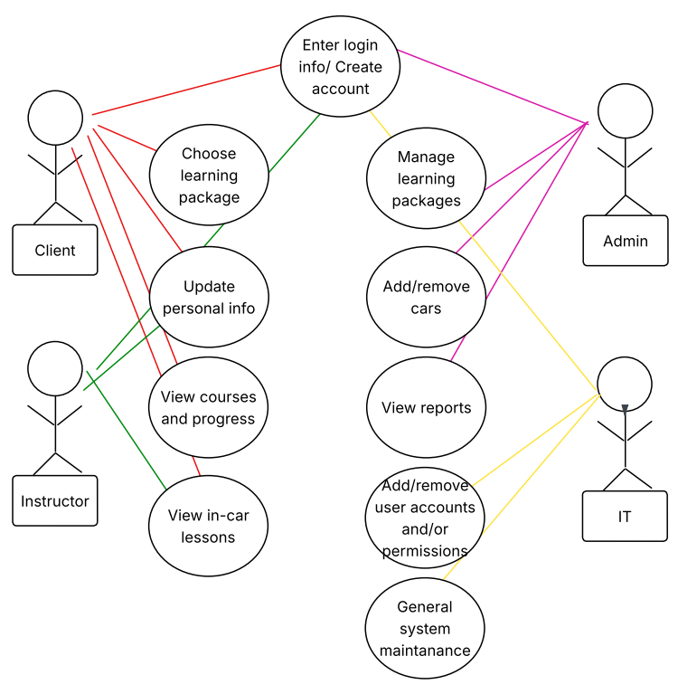

UML Activity Diagrams
Login/Register Account
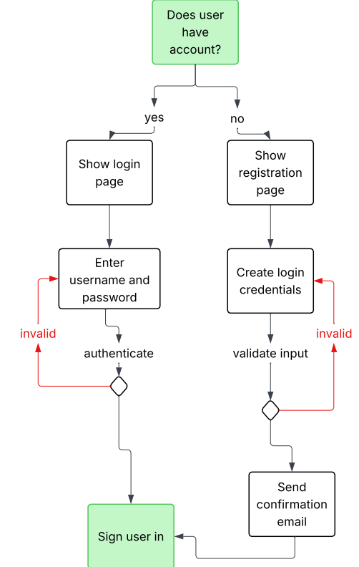

Package Purchase
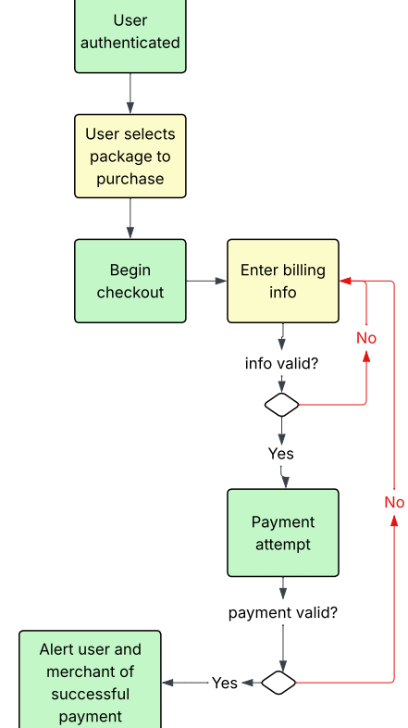

UML Sequence Diagram
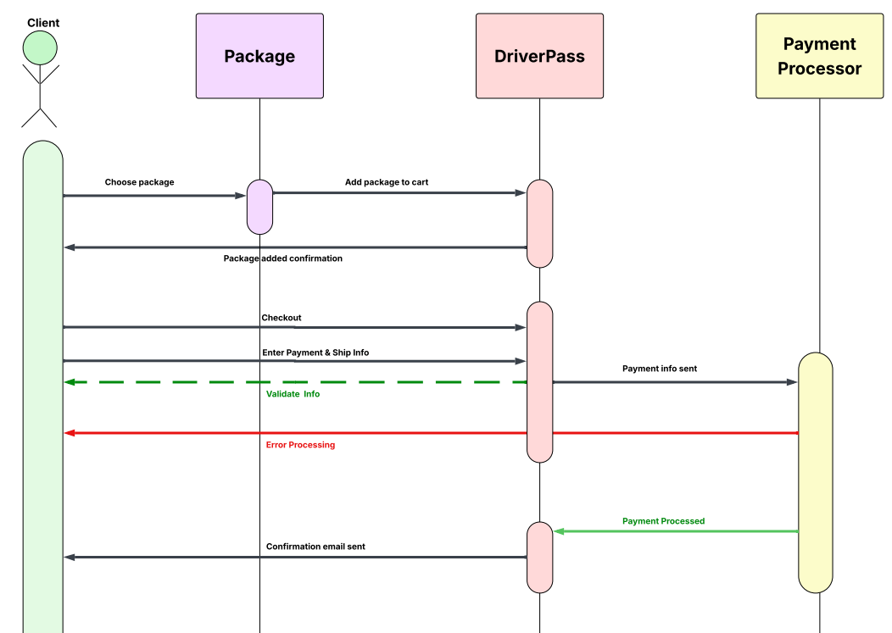

UML Class Diagram
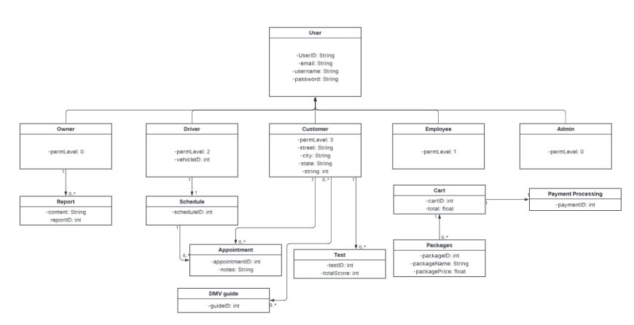

Technical Requirements
- Hardware:
  - Dedicated server
  - Storage for database and website data
  - A device for the user to access
  - Reliable internet connection
  - Firewall
- Software:
  - Use of a Windows server and the latest stable release
  - Security software to prevent any malware
  - SQL Server for maintaining the database and the latest stable release
  - Backup software for website and database
  - Use of a web server such as Apache
- Geographic Considerations:
  - Ensuring website accessibility in America
  - Place the server in a central location for optimized performance
  - Secure the website and database server in a data center

